Add Menu

Upon selecting “ADD” from the “Main Menu”, the user will be presented with the option of adding 1 of three types of reference materials as illustrated below.

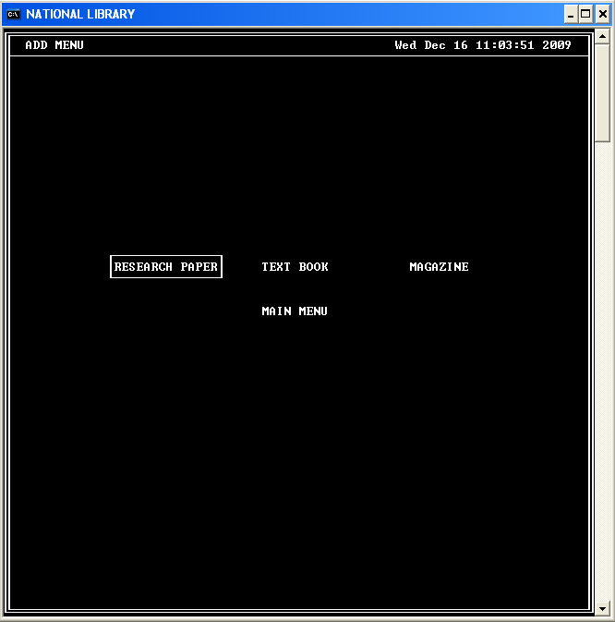

The user can navigate this menu using the navigation keys (up, down, left, right and tab).

